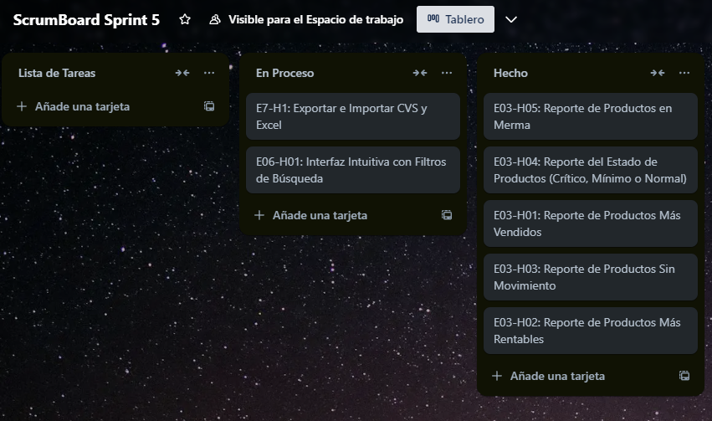

<https://trello.com/b/3wkTfaPH/scrumboard-sprint-5>